Strategic Plan
For the Period of 2016 - 2021

Vision
Our vision is a Toronto West community where - through a collaborative approach - newcomer’s needs are met; they are fully engaged and integrated in our communities.
Mission
Our mission is to:
- Reflect, support and welcome diversity
- Value and involve the talents and experience of newcomers
- Raise awareness of community issues and encourage collective action
- Co-ordinate a service delivery system within TWLIP which is seamless, and client-centered
- Share resources, best practices and opportunities
- Coordinate existing resources for newcomers and immigrants.
Values
We value:
- A process which is collective and community centered
- Inclusiveness
- The lived experience of newcomers and established residents
- Perseverance, tenacity and positive resistance as we attempt to influence, negotiate and raise awareness
- Civic engagement and social justice for all
Background
The TWLIP is an initiative funded by the Immigration, Refugees and Citizenship Canada (formerly Citizenship and Immigration Canada) since 2012. It is one of the five LIPs in the City of Toronto that aims to:
- Foster local engagement of service providers and other institutions in newcomers’ integration process;
- Support community-based knowledge-sharing and local strategic planning; and,
- Improve coordination of services that facilitate immigrant settlement and integration
The TWLIP project is overseen by four partner agencies: Delta Family Resource Centre, Rexdale Women’s Centre, JobStart and Social Planning Toronto. JobStart is the lead agency and holds the contract with Immigration, Refugees and Citizenship Canada (IRCC) for this initiative.

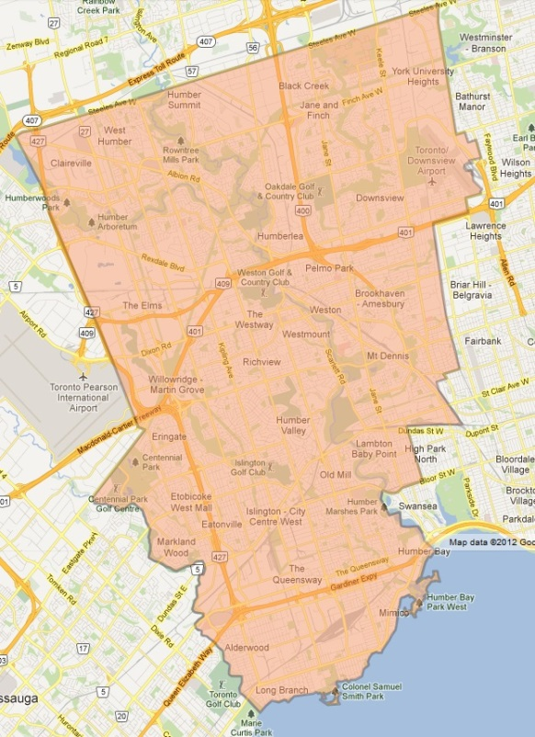  Figure 1. Map of Toronto West LIP | Geographical Area  The TWLIP geographical area boundaries are:  - North from Lake Ontario to Steeles Avenue West  - Extends west to the Mississauga boundary and Highway 427  - East to the Humber River, Dufferin Street and along the CP rail line (Figure 1.)

TWLIP Strategic Priorities
The TWLIP strategy presented in this document is for the period of April 2016 – March 2021 and it is built on its first strategy developed for the period of 2012 – 2015. This strategy directly addresses the key issues identified by the formal partnership of the TWLIP – Planning and Coordinating Committee (PCC), and will be implemented through the activities and initiative identified in the annual work plan. The strategy was approved by the PCC in June 2016.
There are four priority areas in the strategy and each priority will have a service coordination and measurement/evaluation component.
Strategic Priority #1: Service Development & Coordination
Objective: To respond to the emerging needs of newcomers through increased coordination among agencies and groups that serve and work with newcomers
- Identify, support and coordinate response to emerging needs
- Provide opportunities for networking and partnership building
- Create opportunities for knowledge sharing, discuss new services and system/program changes within and across sectors
- Increase opportunities for capacity development among service providers
Strategic Priority #2: Labour Market
Objective: To increase opportunities for access to meaningful employment for newcomers
- Improve access to relevant information for newcomers about employment-related programs and supports
- Coordinate inter-sectoral knowledge sharing, networking and professional development events for frontline staff to support more consistent service delivery to clients
- Increase employer engagement through a collaborative approach
Strategic Priority #3: Education & Language
Objective: To increase newcomers’ access and awareness of educational opportunities
- Increase newcomer parents understanding of how the school system operates in Ontario
- Engage newcomers with education system to support opportunities for lifelong learning
- Explore creative solutions, enhance cross-sectoral collaboration, and facilitate information sharing
Strategic Priority #4: Health and Wellness
Objective: To promote awareness of societal impacts and community response to newcomer health and wellness
- Broaden the scope of areas for sharing promising practices
- Facilitate cross-sectoral collaboration and communication
- Enhance knowledge to build capacity to address emerging health issues among the newcomer population
- Increase awareness and knowledge of available programs, services and resources for newcomers

City-Wide Collaboration Approach
In addition to focusing on implementing the strategies within the TWLIP catchment area, TWLIP staff and members will also actively participate in collaborative meetings and collective discussions with the other three quadrant LIPs in Toronto, and Toronto Newcomer Office (TNO). The purpose and objectives of these meetings are to:
- Establish and maintain good communication among quadrant LIPs and with the TNO;
- Share knowledge and information relevant to the LIPs and their activities;
- Discuss and plan collaborative activities and city-wide initiatives, for example to reduce systemic and widespread barriers that hinder newcomers and immigrants from receiving timely and appropriate support and services.

Toronto West Local Immigration Partnership is one of four quadrant LIPs in the City of Toronto, the other three quadrant LIPs are: 1) Toronto South Local Immigration Partnership; 2) Toronto North Local Immigration Partnership, and 3) Toronto East Quadrant Local Immigration Partnership.

