Select 2016 Census Data for the Toronto West LIP Catchment Area：
Population, Immigration and Citizenship

Select 2016 Census data on population, Immigration and Citizenship for the TWLIP catchment area (North Etobicoke, Central South Etobicoke, Black Creek and York South-Weston) can be downloaded at:
http://www.torontowestlip.ca/wp-content/uploads/Census-Data-2016-TWLIP.xlsx

Methods

Two main sources were used to acquire the data for this project:
- Interactive map of the GTA created by Toronto Star. The map was used to identify the census tract numbers within the TWLIP catchment area, for example:
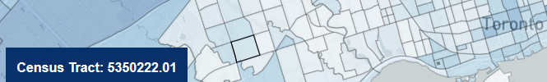
Link to the map:
https://www.thestar.com/news/gta/2017/10/25/a-majority-of-torontonians-now-identify-themselves-as-visible-minorities-census-shows.html

- Census profile page on the Statistics Canada website. Census tract numbers were used to extract data from the Statistics Canada website through the following steps:
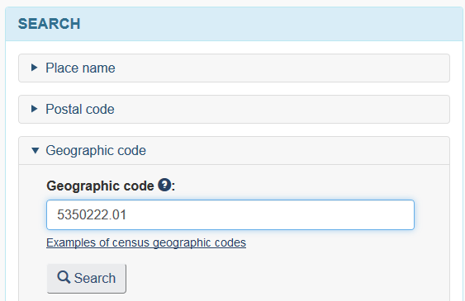
- Go to http://www12.statcan.gc.ca/census-recensement/2016/dp-pd/prof/index.cfm?Lang=E
- Under SEARCH

Click on Geographic code

Enter a census tract number

Click on search

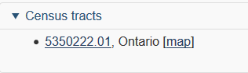

- Click on the census tract no.

- Select immigration and citizenship/population
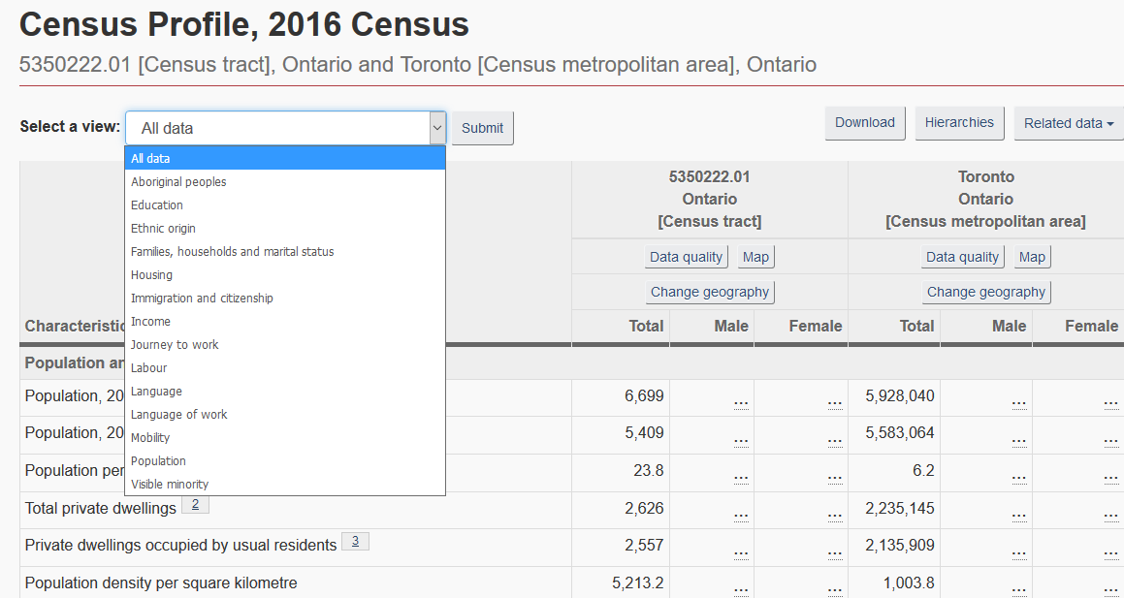

- Manually enter the data in the excel file. See example below:
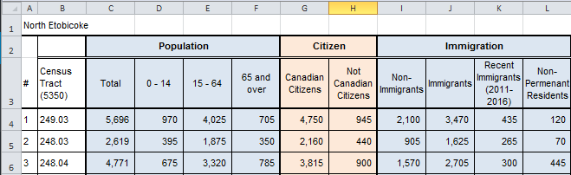

Note: Since the data is entered manually, 100% accuracy cannot be guaranteed due to the possibility of
human error.

