August 2018

Census Report
Presentation of Select 2016 Population and Immigration Census Data of the Toronto West LIP Catchment Area

Table of Contents

Introduction 2
Toronto West Catchment Area 3
Select Data of Toronto West 4
North Etobicoke 4
Central South Etobicoke 5
Black Creek 6
York South-Weston 7
Comparison between the Four Areas 8
Population by Age Group 8
Immigration Status 9
Admission Category 10
Toronto West LIP Area Compared to City of Toronto 11
Population by Age Group 11
Immigration Status 12
Admission Category 13
Conclusion 14

Introduction

According to “Immigration and ethnocultural diversity: Key results from the 2016 Census” by Statistics Canada, 1,212,075 recent immigrants have permanently settled in Canada between 2011 and 2016. The majority of these immigrants are economic immigrants (60.3%), followed by sponsored immigrants (26.8%) and refugees (11.6%). The report also indicates that as of 2016, more than half of recent immigrants originate from Asia (including the Middle East) and that more immigrants have arrived from Africa than Europe for the first time. It was also reported that Toronto is still one of the main destinations for recent immigrants, with 187,950 of them settling in the city between 2011 and 2016.
To better understand the demographics of the Toronto West Local Immigration Partnership (TWLIP) catchment area (see map on p.3), TWLIP initiated a project in the 2016-2017 program year to compile select 2016 census data on population, immigration and citizenship.
The purpose of this report is to present key information collected from the project. The report includes two main components: 1) a presentation of the population of Toronto West by age group, immigration status (with the categories of non-immigrants, immigrants, recent immigrants or non-permanent residents), admission category, country of origin and mother tongue; and 2) the population comparison of Toronto West and the City of Toronto.
Toronto West LIP Catchment Area
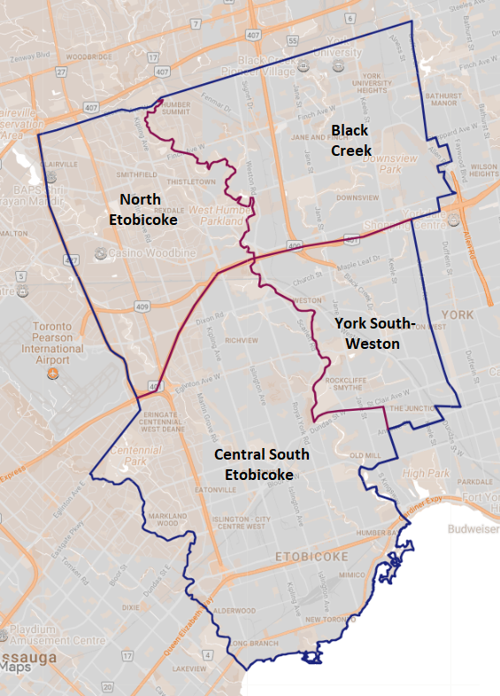
Geographic boundaries of Toronto West LIP (including the areas within the catchment):
- North to Steeles Avenue West
- South to Lake Ontario
- West to the Mississauga boundary and Highway 427
- East to the Humber River, Dufferin Street and along the CP rail line

Map of the Toronto West LIP catchment area

Select Census Data

North Etobicoke
Total Population: 96,611

0-14 (18%) | 15-64 (68%) | 65 and over (14%)
Non –Immigrants (39%) |  | Immigrants (58%) |  |  | Recent  Immigrants (9%) |  |  | Non-Perm  Residents (3%)
Observations
68% of the population in North Etobicoke are between the ages of 15-64. Nearly half of the population are immigrants and more than one third came to Canada as sponsored immigrants.
23% of immigrants came from India; 12% from Europe and 11% from Africa. The most widely spoken mother tongues are Punjabi and Gujarati, spoken by 9% & 5% of the total population. Close to 5% of the population speak English and a non-official language as their mother tongues (two mother tongues).

Central South Etobicoke
Total Population: 286,438

Non –Immigrants (58%) | Immigrants (40%) | Recent  Immigrants (5%) | Non-Perm  Residents (2%)
0-14 (15%) | 15-64 (67%) | 65 and over (18%)
Observations
Out of the four areas within the TWLIP catchment area, Central South Etobicoke is the only area with more than 50% of non-immigrants. Also, it is the only area where the number of economic immigrants is greater than that of sponsored immigrants.
Approximately 8% of immigrants come from Poland and Africa, followed by Ukraine and Italy (5.6%).

Black Creek
Total Population: 149,076

Non –Immigrants (39%) | Immigrants (58%) | Recent  Immigrants (8%) | Non-Perm  Residents (3%)
0-14 (18%) | 15-64 (67%) | 65 and over (15%)
Observations
13% of immigrants in Black Creek come from Italy, making it the top country of origin for immigrants in this area. Italian and Spanish are the most widely spoken mother tongues, and approximately 5% of the total population speak English and a non-official language as their mother tongue.
21% of immigrants are economic immigrants. This is the lowest percentage among the four areas. 34% of immigrants came to Canada as sponsored immigrants.

York South-Weston
Total Population: 139,219

0-14 (17%) | 15-64 (69%) | 65 and over (14%)
Non –Immigrants (48%) | Immigrants (50%) | Recent  Immigrants (6%) | Non-Perm  Residents (2%)
Observations
Approximately 15% of Immigrants in York South-Weston come from Portugal (which is the top country of origin), followed by Africa (10%) and Italy (9%). Portuguese is the most widely spoken mother tongue in the area.
31% of immigrants came to Canada under the sponsorship program (this area having the greatest number among the four areas), followed by economic immigrants (25%) and refugees (17%).

Comparison between the Four Areas

Population by Age Group
Area | 0-14 | 15-64 | 65 and over
North Etobicoke | 18% | 68% | 14%
Central South Etobicoke | 15% | 67% | 18%
Black Creek | 18% | 67% | 15%
York South-Weston | 17% | 69% | 14%
TWLIP Area | 16% | 68% | 16%

All four areas in the TWLIP have more people aged 15-64 (over two thirds of the population) than people aged 0-14 or 65 and over (with each of these peripheral groups comprising of 18% or less of the population in their respective area). All four areas also display similar population compositions reflected by minimal variance (less than 3 %) in percentage distributions across the three age groups.

Immigration Status

Area | Non-Immigrants | All Immigrants | Recent Immigrants (2011- 2016) | Non-Permanent Residents
North Etobicoke | 39% | 58% | 9% | 3%
Central South Etobicoke | 58% | 40% | 5% | 2%
Black Creek | 39% | 58% | 8% | 3%
York South-Weston | 48% | 50% | 6% | 2%
TWLIP Area | 49% | 49% | 6% | 2%

Admission Category
North Etobicoke and Black Greek have the greatest percentage of immigrants (almost 60% of the population in that area) and also the greatest percentage of recent immigrants. Central South Etobicoke has the lowest proportion of immigrants (40% of the total population of that area.) York South-Weston, unlike the other areas, has a nearly equal distribution of immigrants and non-immigrants.

Area | Economic | Sponsored | Refugees
North Etobicoke | 31% | 43% | 26%
Central South Etobicoke | 46% | 31% | 23%
Black Creek | 28% | 45% | 27%
York South-Weston | 34% | 43% | 23%
TWLIP Area | 36% | 40% | 24%
With the exception of Central South Etobicoke, sponsored immigrants make up the majority of immigrants in the TWLIP (43%-45% of the population in each of the other 3 areas).
Noticeably different, economic immigrants are the majority in Central South Etobicoke, making up about half of the area’s total immigrant population.
The admission category of refugees comprises roughly a quarter of the immigrant populations of all areas. Black Creek (at 27%) and North Etobicoke (at 26%) have a greater percentage of immigrants classified as refugees compared to Central South Etobicoke (at 23%) and York South-Weston (at 23%).

Toronto West LIP Area Compared to the City of Toronto

Population by Age Group

Toronto West Population: 671,344
City of Toronto Population: 2,731,670

Area | 0-14 | 15-64 | 65 and over
TWLIP Area | 16% | 68% | 16%
Toronto | 15% | 70% | 16%
The residents in the TWLIP area constitute 25% of the entire City of Toronto population.
The data indicates that there is little to no difference in the age distributions of both TWLIP LIP catchment area and the City of Toronto populations.

Immigration Status

Area | Non-Immigrants | All Immigrants | Recent Immigrants  (2011-2016) | Non-permanent Residents
TWLIP Area | 49% | 49% | 6% | 2%
Toronto | 49% | 47% | 7% | 3%
When comparing the TWLIP and the city of Toronto, there is almost no difference in the ratio of non-immigrants relative to the overall population (1:2 in both cases). The TWLIP has a slightly higher percentage of immigrants than Toronto; however, Toronto has a higher percentage of recent immigrants and non-permanent residents than the TWLIP.

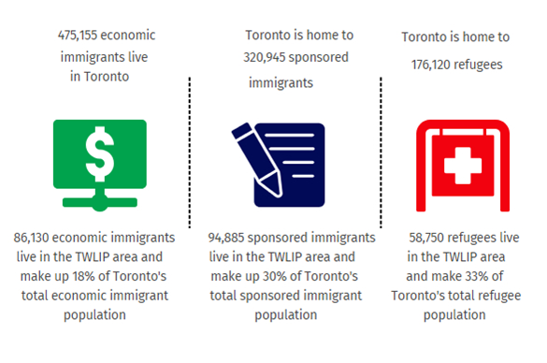
Admission Category

Distribution of Immigration Status by Percentage and Ratio
 | Economic | Sponsored | Refugee
TWLIP Area | 36% | 40% | 24%
Toronto | 49% | 33% | 18%
The TWLIP area has a lower proportion of economic immigrants than Toronto. A higher proportion of refugees and sponsored immigrants live in the TWLIP area than in Toronto.

Conclusion

In summary, this report presents a high level summary of select 2016 census data on population, immigration, and citizenship for the TWLIP. To highlight differences and similarities, data from the four areas within the TWLIP catchment area - Black Creek, Central South Etobicoke, North Etobicoke and York South-Weston - has been compared to each other and data from the TWLIP as a whole has been compared to the City of Toronto. It is also possible to draw comparisons between data from the City of Toronto and data from each of the four TWLIP areas.
Data has been presented in chart form for ease of access to the information. Some noteworthy observations accompany the charts. Stakeholders are encouraged to use the data for service planning, funding applications etc.
As mentioned in the introduction, an in-depth look at select data (population, immigration, and citizenship) for each census tract/neighbourhood in the TWLIP is available through the TWLIP’s census project at:
www.torontowestlip.ca/select-2016-census-data/
This report is prepared by Joshua Velasquez, Research Analyst Program Student, Humber College, based on the Select Census Data compiled by Artan Mustafa, Social Service Worker – Immigrants and Refugee Program Student, Seneca College.

Statistic Canada. 2017. “Immigration Highlights. “Immigration and ethnocultural diversity: Key results from the 2016 Census.” https://www150.statcan.gc.ca/n1/daily-quotidien/171025/dq171025b-eng.htm.
'Economic immigrants' includes immigrants who have been selected for their ability to contribute to Canada's economy through their ability to meet labour market needs, to own and manage or to build a business, to make a substantial investment, to create their own employment or to meet specific provincial or territorial labour market needs.
'Sponsored immigrants' includes immigrants who were sponsored by a Canadian citizen or permanent resident and were granted permanent resident status on the basis of their relationship either as the spouse, partner, parent, grand-parent, child or other relative of this sponsor. The terms 'family class' or 'family reunification' are sometimes used to refer to this category.
'Refugees' includes immigrants who were granted permanent resident status on the basis of a well-founded fear of returning to their home country. This category includes persons who had a well-founded fear of persecution for reasons of race, religion, nationality, membership in particular social group or for political opinion (Geneva Convention refugees) as well as persons who had been seriously and personally affected by civil war or armed conflict, or have suffered a massive violation of human rights. Some refugees were in Canada when they applied for refugee protection for themselves and their family members (either with them in Canada or abroad). Others were abroad and were referred for resettlement to Canada by the United Nations Refugee Agency, another designated referral organization or private sponsors.
For more details of the project, visit www.torontowestlip.ca/select-2016-census-data/
'Non-immigrants' includes persons who are Canadian citizens by birth.
'Immigrants' includes persons who are, or who have ever been, landed immigrants or permanent residents. Such persons have been granted the right to live in Canada permanently by immigration authorities. Immigrants who have obtained Canadian citizenship by naturalization are included in this category. In the 2016 Census of Population, 'Immigrants' includes immigrants who landed in Canada on or prior to May 10, 2016.
‘Recent Immigrants’ Includes immigrants who landed in Canada on or prior to May 10, 2016.
'Non-permanent residents' includes persons from another country who have a work or study permit or who are refugee claimants, and their family members sharing the same permit and living in Canada with them.
“Immigrants” represents the total number of immigrants, including “Recent Immigrants”.
“All Immigrants” represents the total number of immigrants, including “Recent Immigrants (2011-2016)”.

